**Chapter 10 exercise – the performance logs and alerts service**

In this exercise, you will learn how to do the following:

Start the performance logs and alerts service

Access the Performance Monitor logs folder

Create performance data logs

Set up performance counter alerts

## Starting the performance logs and alerts service

To start the performance logs and alerts service in Windows Server 2019, complete the following steps:

1. Press the Windows key + *R*.
2. Enter services.msc and press *Enter*.
3. From the list of services, locate the **Performance Logs & Alerts** (see *Figure 10.14*) service to check its status.
4. If it is stopped, then right-click and select **Start**.
5. Close the **Services** window:

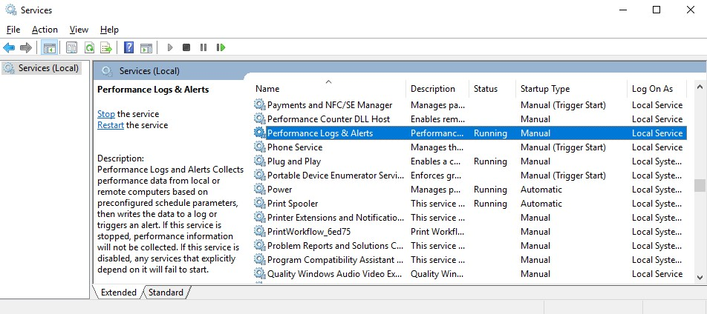

Figure 10.14: Performance logs and alerts service in Windows Server 2019

Now that we have started the performance logs and alerts service, let's move to our next task of accessing the Performance Monitor logs folder.

## Accessing the Performance Monitor logs folder

To access the Performance Monitor logs folder, PerfLogs, in Windows Server 2019, complete the following steps:

1. Press the Windows key + *R*.
2. Enter C: and press *Enter.*
3. The PerfLogs folder appears, as shown in *Figure 10.15*:

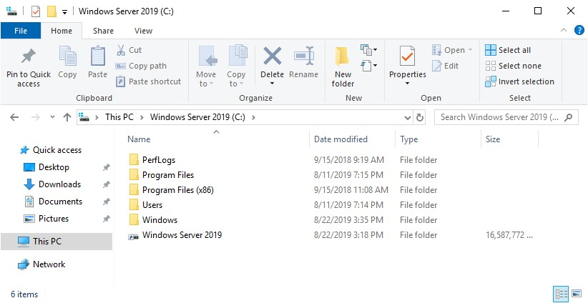

Figure 10.15: PerfLogs folder in Windows Server 2019

Moving forward, let's now create some performance data logs.

## Creating performance data logs

To create performance data logs in Windows Server 2019, complete the following steps:

1. With **Performance Monitor** open, expand **Data Collector Sets** and select **User Defined**.
2. Right-click **User Defined** and select **New** | **Data Collector Set**.
3. Enter the name for your Data Collector Set.
4. Choose the **Create manually (Advanced)** option and then click **Next**.
5. Choose the **Create data logs** option and the **Performance counter** sub-option, and then click **Next**.
6. Click the **Add** button to add counters, as shown in *Figure 10.16*, specify the time interval, and then click **Next**:

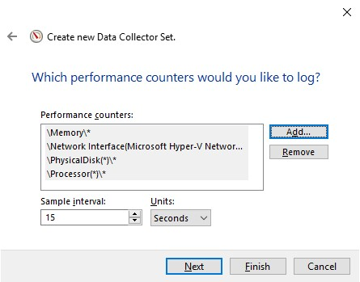

Figure 10.16: Adding performance counters

1. Check that the default folder for saving data logs is the PerfLogs folder, and then click **Next**.
2. Set the user in **Run as**, and select the **Start this data collector set now** option.
3. Click **Finish**.

Finally, let's now set up performance counter alerts.

## Setting up performance counter alerts

To set up a performance counter alert in Windows Server 2019, complete the following steps:

1. Repeat *steps 1* to *4* from the *Creating performance data logs* section.
2. Choose **Performance Counter Alert**, and then click **Next**.
3. Click the **Add** button to add counters, as shown in *Figure 10.17*, specify an alert limit, and then click **Next**:

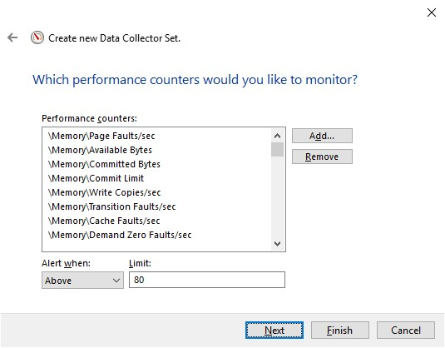

Figure 10.17: Setting up the performance counter alert

1. Set the user in **Run as**, and select the **Start this data collector set now** option.
2. Click **Finish**.

This was a nice exercise as it covered various examples of performance logs and alerts in Windows Server 2019.